**Tugas 9**

**Tugas 9.1**

**Code :**

<html>

<title>W3.CSS</title>

<meta name="viewport" content="width=device-width, initial-scale=1">

<link rel="stylesheet" href="w3.css">

<body>

    <div class="">

        <div class="w3-container w3-lime">

            <h1>Hanif Ahmad Syauqi</h1>

        </div>

        <img src="images/mypic.webp" alt="">

        <div class="w3-container w3-green">

            <p>Hanif lahir di bandung, tanggal 30 juni 2003, Dia adalah anak pertama dari 4 bersaudara semua laki-laki, hobynya adalah bermain badminton dan coding, dan sekarang dia sedang menjalani perkuliahan di kampus UNIKOM</p>

        </div>

    </div>

</body>

</html>

**Screenshot :**

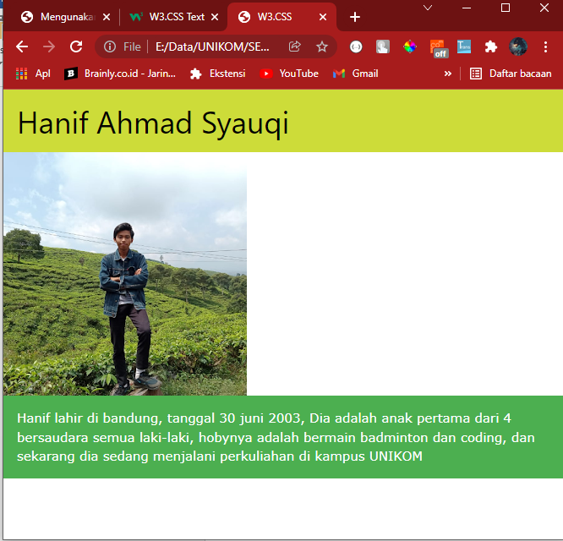

**Tugas 9.2**

**Code :**

<!DOCTYPE html>

<html lang="en">

<head>

    <meta charset="UTF-8">

    <meta http-equiv="X-UA-Compatible" content="IE=edge">

    <meta name="viewport" content="width=s, initial-scale=1.0">

    <title>Tugas 9.2</title>

    <link rel="stylesheet" href="w3.css">

</head>

<body>

    <div class="w3-container">

        <div class="w3-panel w3-blue w3-card-4 w3-padding-16 w3-center">

            <img src="images/mypic.webp" alt="">

        </div>

        <div class="w3-panel w3-teal w3-round-xlarge w3-padding-16 w3-center">

            <img src="images/suzy.png" alt="">

        </div>

    </div>

</body>

</html>

**Screenshot :**

